


Master 2 Machine Learning on sequences

Practical work 5:
Transformer Encoder-Decoder, CNN-Transformer, and Vision Transformer
for digit sequence images recognition

All along this classroom work we will train then test a Transformer encoder-decoder Network for the recognition of handwritten digit sequences. We will use the same dataset as for the RNN-CTC available in the file "MNIST_5digitsDifficile.pkl".
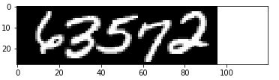
Figure 1: One example from the MNIST-5 digits difficile

This classroom work was developed from the tutorial available at this link:
https://towardsdatascience.com/a-detailed-guide-to-pytorchs-nn-transformer-module-c80afbc9ffb1

The transformer encoder-decoder architecture

The Encoder-Decoder architecture depicted on figure below achieves the encoding of the sequence of pixel columns of size 28 into a sequence of embeddings of size hidden_size of same length. Then, the decoder starts predicting the next output symbol, knowing the input representation provided by the encoder and its previous output predictions $Y_{t-1}$.
The encoder-decodeur bloc is implemented in the pytorch library through the class pytorch.nn.Transformer(). The input of this bloc are input embeddings (x_embedding) and output embeddings (y_embedding) that need to be positional encoded respectively.
The architecture is defined by :
- hidden_size : size of the internal representations, both on the encoder side and decoder side.
- Num_layers : number of encoder and decoder transformer layers (they can be different on the encoder and decoder side)
- Num_heads : number of heads in the encoder and decoder side.
- Dropout: the fraction of droped out (freezed) parameters at each update of the parameter. This prevents from over fitting the training dataset during training.
- Num_classes: number of classes to be discriminated. Notice that in addition to the 10 digit classes two additional tokens are required. The START_TOKEN (10) which is a token that provides the decoder with the appropriate context to start decoding, and the END_TOKEN which allows to stop the decoding process once it has been predicted. All in all 12 classes are required for the task at end.

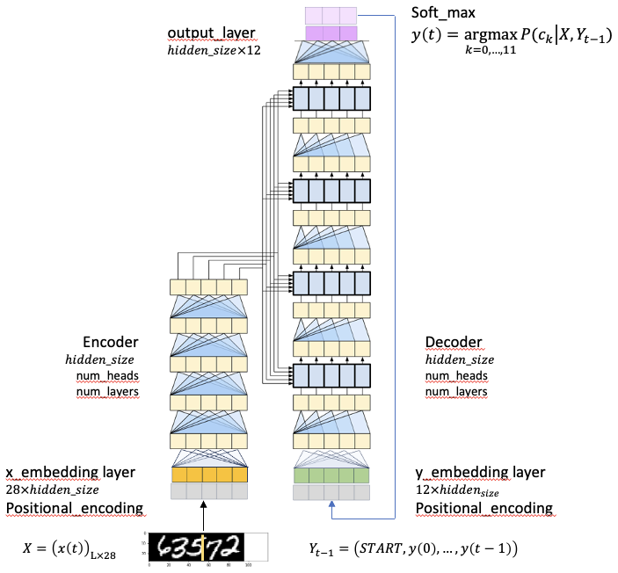
Figure 2: the encoder decoder architecture.

Working with the Google Colab environment
For this classroom work you need the three following files that can be downloaded from your environement:

TRANFORMER.py
Main-Transformer.ipynb
MNIST_5digitsDifficile.pkl

They must be put into your google drive ColabNotebooks directory. The trained model files are store on your local Colab directory : “/content/sample_data”

- Accessing your Google Drive files
Your drive directory can be mounted on your Colab local directory “/content/drive” through the following command lines included in the Main-Transformer.ipynb file.
from google.colab import drive
!mkdir -p drive
drive.mount('/content/drive',force_remount=True)
#!cd /content/drive/MyDrive/ColabNotebooks
- Configuration of the Colab processing power
Training transformer architecture requires a lot of training data as well as powerful computing infrastructure. In your Colab environment you can ask for more computation power for free if available. At least Colab may provide you with T4 Nvidia GPU if some of them are available. Also note that this free computing pawer is accessible for a limited amount of time (2 hours or so). Therefore, you may get disconnected from this computing environment at any time without being warned. Afterwards you may come back to computing with a CPU.

To ask for GPU select “Modifier le type d’exécution”

Then select your processor
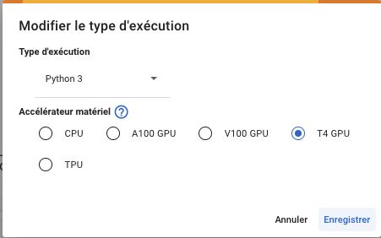

Accessing the TRANSFORMER module from your Google Drive
sys.path.append('/content/drive/MyDrive/ColabNotebooks')
import TRANSFORMER

Your ColabNoteBooks directory should content the TRANSFORMER.py module as well as the Main-Transformer.ipynt notebook.

Architecture implementation details with Pytorch

The file TRANFORMER.py is the module code that implements the encoder-decoder architecture. It is composed of the following methods and classes.

Transformer class
self.positional_encoding_layer = PositionalEncoding(dim_model = self.hidden_size,
dropout_p = self.dropout,
max_len = self.max_length)
self.x_embedding = nn.Linear(config['input_features'],config['hidden_size'])
self.y_embedding = nn.Embedding(config['num_classes'],config['hidden_size'])
self.transformer = nn.Transformer(d_model=config['hidden_size'],
nhead=config['num_heads'],
num_encoder_layers =config['num_layers'],
num_decoder_layers =config['num_layers'],
dim_feedforward = config['hidden_size'],
dropout=config['dropout'],
batch_first = True)
# Output layer for text prediction
self.output_layer = nn.Linear(config['hidden_size'], config['num_classes'])

def forward(self, x,y,y_output_mask,src_key_padding_mask,tgt_key_padding_mask):
# Embedding + positional encoding - Out size = (batch_size, sequence length, dim_model)
#x = self.x_embedding(x) * math.sqrt(self.hidden_size)
x = self.x_embedding(x)
x = self.positional_encoding_layer(x)
y = self.y_embedding(y) * math.sqrt(self.hidden_size)
y = self.positional_encoding_layer(y)
# Transformer blocks - Out size = (sequence length, batch_size, num_tokens)
transformer_out = self.transformer(x, y,
tgt_mask = y_output_mask,
src_key_padding_mask=src_key_padding_mask,
tgt_key_padding_mask=tgt_key_padding_mask)
output = self.output_layer(transformer_out)
return output

Other methods
def train_loop(dataloader, model, loss_fn, optimizer):
print("Training loop...")
size = len(dataloader.dataset)
nb_batches = len(dataloader)
epoch_loss = 0
model.train()

for batch, (X, y,X_l,y_l) in tqdm(enumerate(dataloader)):
X = X.to(model.DEVICE)
y = y.to(model.DEVICE)
y_input = y[:,:-1]# on retire le END_TOKEN car nest jamais traité en entrée
y_output = y[:,1:]# on ne cherche jamais à predire le START_TOKEN

l = y_input.size(1) # la longueur maximale d'un élément du batch
y_output_mask = model.get_tgt_mask(l).to(model.DEVICE)
x_padding_mask = (X[:,:,0] == model.pad_idx).to(model.DEVICE)
y_input_padding_mask = (y_input == model.pad_idx).to(model.DEVICE)

# Compute prediction and loss
pred = model(X.float(), y_input,
y_output_mask,
x_padding_mask,
y_input_padding_mask)
pred = pred.permute(1, 2, 0)
y_output = y_output.permute(1, 0)
loss = loss_fn(pred, y_output)
epoch_loss += loss.item()

# Backpropagation
optimizer.zero_grad()
loss.backward()
optimizer.step()

return epoch_loss / nb_batches

def valid_loop(dataloader, model, loss_fn):
………………………
return valid_loss

The file Main-Transformer.py

if __name__ == '__main__':

TRAINING = True # Training if True Testing otherwise
SHOW = False

device = torch.device("cpu")
if torch.backends.mps.is_available():
device = torch.device("mps")
elif torch.cuda.is_available():
device = torch.device("cuda")
print("Device :",device)

config = {
‘w_width':5,
'w_stride':5,
'input_features':140,
'batch_size':256,
'num_epochs':1500,
'learning_rate':1e-4,
'num_classes':12, # START_TOKEN + END_TOKEN
'hidden_size':64,
'num_heads':4,
'num_layers':8,
'dropout':0.5,
'pad_idx':-1,
'max_length':140,
'START_TOKEN':10,
'END_TOKEN':11,
}

dir_name = "/content/sample_data/"
model_name = "Transformer_"+str(config['input_features'])+"_"+str(config['hidden_size'])+"_"+str(config['num_heads'])+"_"+str(N_train)
model_name =dir_name+model_name

my_transformer = TRANSFORMER.Transformer(config,device).to(device)
loss_fn = torch.nn.CrossEntropyLoss(ignore_index=config['pad_idx'],reduction='mean')
optimizer = torch.optim.Adam(my_transformer.parameters(),lr=config['learning_rate'])

train_loss = []
valid_loss = []
for e in range(config['num_epochs']):
train_loss.append(TRANSFORMER.train_loop(train_dataloader,
my_transformer,
loss_fn,
optimizer))

Tranformer Encoder-Decoder (T)
- Train a transformer with a (w_width = 5, w_stride = 5) sliding window on a small dataset (train = 10 000, valid = 1000). Observe the problems encountered. Convergence, and performance.

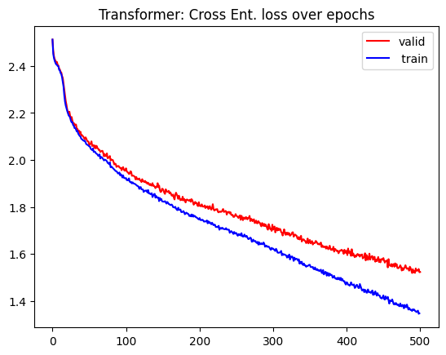
Figure 3: Loss over epochs for Transformer with 10.000 examples.

Character Recognition Rate = 65.475 %
String Recognition Rate = 0.0 %
Nombre de paramètres du modèle: 6374668

Using only a small part of the MNIST_5digitsDifficile.pkl dataset, we see that the training was not completed in 500 epochs, that means that a longer training time would be necessary for the model to reach the point of convergence of the loss.

It is noticeable that the number of epochs required to train a transformer is much greater than for methods used in previous TPs, where only 60 epochs were sufficient for a similar problem.

- Train a transformer with a (w_width = 5, w_stride = 5) sliding window on a large dataset (train = 54 000, valid = 6000). Observe the problems encountered. Convergence, and performance.

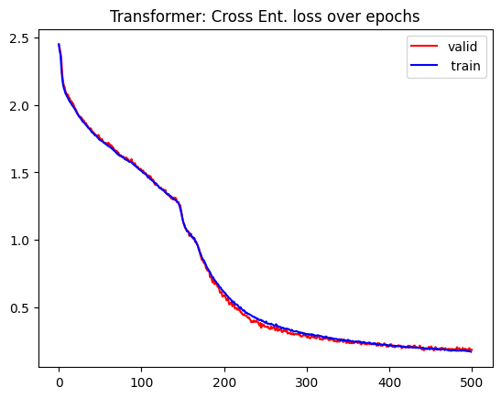
Figure 4: Loss over epochs for Transformer with 54.000 examples.

Character Recognition Rate = 81.74 %
String Recognition Rate = 0.85 %
Nombre de paramètres du modèle: 6374668

The use of the complete dataset brought a great improvement in performance, revealing that transformers are an architecture that depends on a large number of examples to generalize well, especially for complex tasks like this one.

We observed in the loss curve for this training that both the train and valid curves advance quite closely throughout the process, indicating that the datasets follow similar distributions. We also observed the presence of multiple knees in the curves, indicating segmented learning where initially short-range dependencies are being learned and then long-term dependencies are identified.

Comparing once again with the TPs performed previously, this architecture proved to be significantly inferior compared to CNN-BLTM (SRR=85.90%, CRR=96.66%) and Neuro-HMM (SRR=48.45%, CRR=85.95%). This may be related to the fact that these architectures are better prepared for image processing.

Hybride CNN-Transformer architecture (CNN-T)
- Implement a modified version of the transformer which introduces some CNN encoding layers before the transformer bloc.

class CNNEncoder(nn.Module):
def __init__(self, input_channels=1, hidden_size=256, input_height=28, input_width=28):
super().__init__()

self.input_height = input_height
self.input_width = input_width

self.cnn = nn.Sequential(
# Layer 1: Conv + BatchNorm + ReLU + Pool
nn.Conv2d(input_channels, 32, kernel_size=3, stride=1, padding=1),
nn.BatchNorm2d(32),
nn.ReLU(inplace=True),
nn.MaxPool2d(kernel_size=2, stride=2),

# Layer 2: Conv + BatchNorm + ReLU + Pool
nn.Conv2d(32, 64, kernel_size=3, stride=1, padding=1),
nn.BatchNorm2d(64),
nn.ReLU(inplace=True),
nn.MaxPool2d(kernel_size=2, stride=2),

# Layer 3: Conv + BatchNorm + ReLU
nn.Conv2d(64, 128, kernel_size=3, stride=1, padding=1),
nn.BatchNorm2d(128),
nn.ReLU(inplace=True),
)
# Calculate flattened
self.flattened_size = 128 * (input_height // 4) * (input_width // 4)

# Projection to transformer
self.projection = nn.Linear(self.flattened_size, hidden_size)

def forward(self, x):
batch_size, seq_len, height, width = x.shape
x_reshaped = x.view(batch_size * seq_len, 1, height, width)
cnn_features = self.cnn(x_reshaped)
cnn_features = cnn_features.view(batch_size * seq_len, -1)
projected = self.projection(cnn_features)

return projected.view(batch_size, seq_len, -1)

The three-layer architecture described above was implemented with the goal of generating a smaller-sized embedding of the original image. This way, the transformer would work with a more concise representation of the original image, where information relevant for classification would not be lost and could still be identified by the transformer.
- Show how CNN layers help convergence by providing a better embedding of the input image.

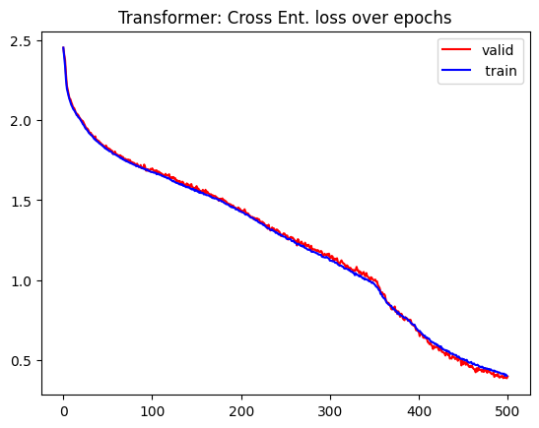
Figure 4: Loss over epochs for CNN-Transformer with 54.000 examples.

Character Recognition Rate = 57.14 %
String Recognition Rate = 0.0 %
Nombre de paramètres du modèle: 8769036

Although the CNN addition has a clear objective, it apparently cannot be fulfilled in just 500 epochs. The more complex architecture brought with it a greater number of parameters to be learned by the model, justifying the need for more training epochs. Another possible explanation is that the CNN may be extracting spatial features well from the initial image, but having difficulty extracting sequential features that can be interpreted by the transformer.

It is important to mention that a more in-depth search of hyperparameters in this new architecture may yield better results for model performance.

Vision Transformer architecture (ViT)
- Implement your own vision transformer with a square $n×n$ pixels sliding window and appropriate 2D stride, with a 2D positional encoding. Compare the performance obtained with the hybride CNN-Transformer one.

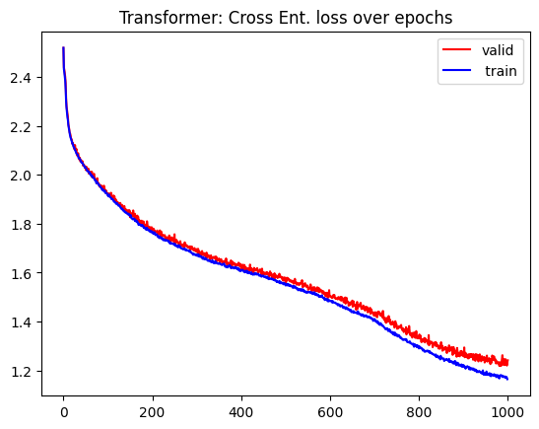
Figure 4: Loss over epochs for ViT with 54.000 examples.

Character Recognition Rate = 49.72 %
String Recognition Rate = 0.0 %
Nombre de paramètres du modèle: 6397454

The ViT architecture, also used in TP6, did not obtain good results for this dataset either, as its training was not completed, even with twice the number of epochs used for the previous architectures. ViTs are well-suited architectures for this type of task, but they strongly depend on more data and more training epochs. ViT first needs to learn a good visual representation of the digits before allowing the architecture to capture temporal dependencies or global rules of the sequence.

